4th Grade-Lesson 11/Mrs. Faour

Objective: Explain fraction equivalence using a tape diagram and the number line, and relate that to the use of multiplication and division.

Problem –Set page/Watch Video

Fluency Practice /Watch Video

Application Problem/Watch Video

Lesson Requirements:

* Homework page/Submit
* Exit Ticket page/Submit

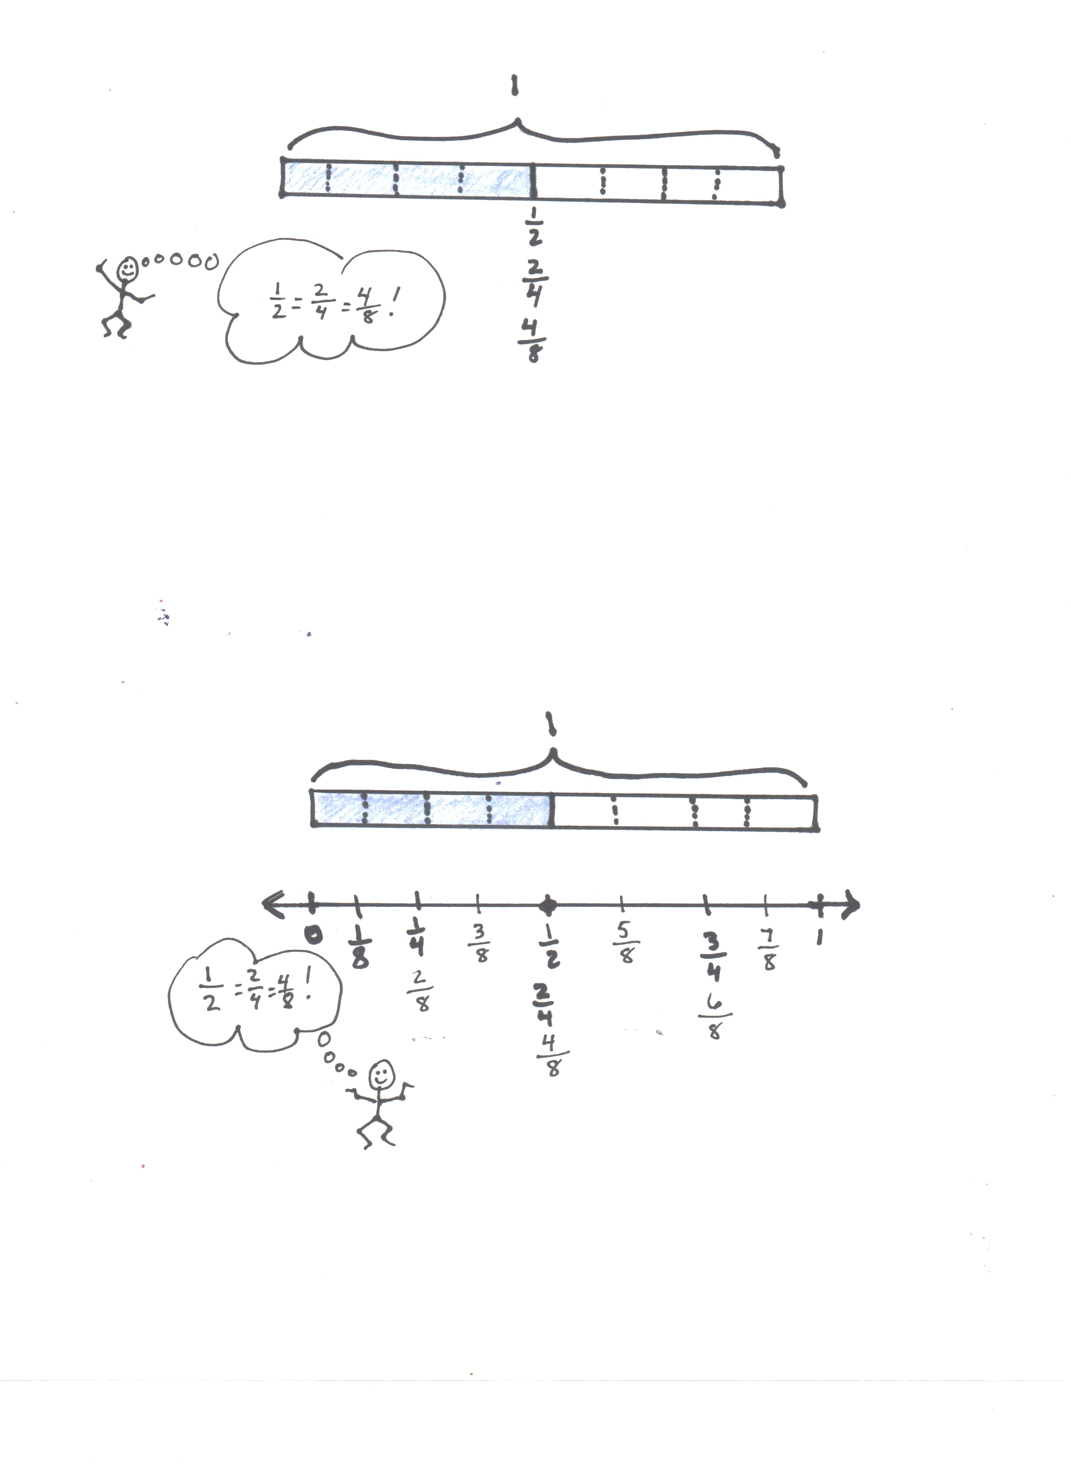

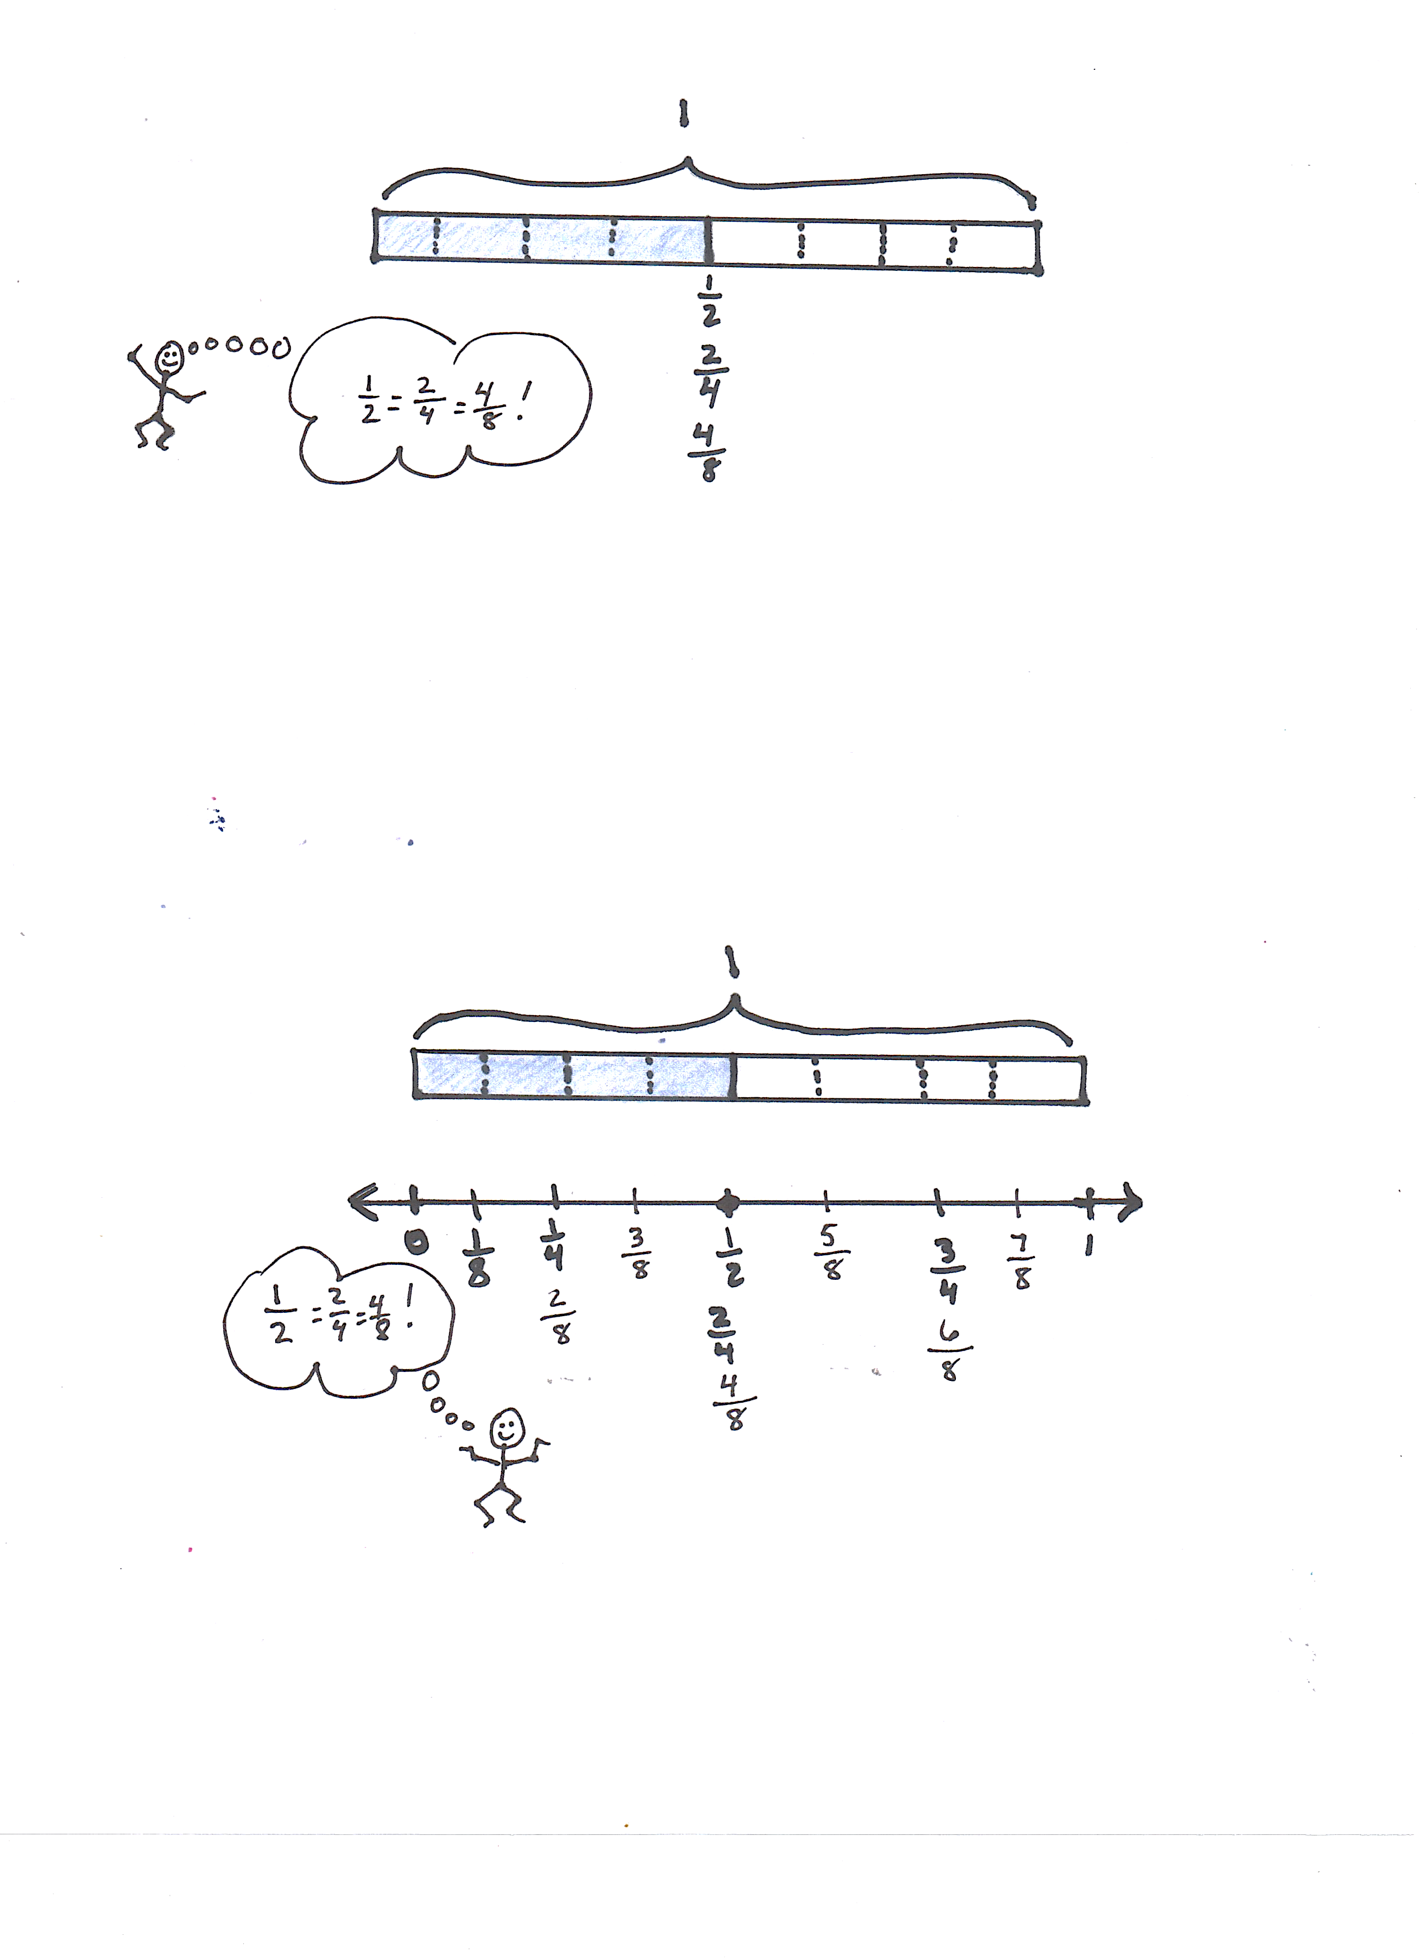

Name Date

1. Label each number line with the fractions shown on the tape diagram. Circle the fraction that labels the point on the number line that also names the shaded part of the tape diagram.



1



1



1

1. Write number sentences using multiplication to show:
2. The fraction represented in 1(a) is equivalent to the fraction represented in 1(b).
3. The fraction represented in 1(a) is equivalent to the fraction represented in 1(c).
4. Use each shaded tape diagram below as a ruler to draw a number line. Mark each number line with the fractional units shown on the tape diagram, and circle the fraction that labels the point on the number line that also names the shaded part of the tape diagram.

1

|  |  |  |
| --- | --- | --- |
|  |  |  |

1



|  |  |  |  |  |  |
| --- | --- | --- | --- | --- | --- |
|  |  |  |  |  |  |

1

|  |  |  |  |  |  |  |  |  |  |  |  |
| --- | --- | --- | --- | --- | --- | --- | --- | --- | --- | --- | --- |
|  |  |  |  |  |  |  |  |  |  |  |  |

1. Write number sentences using division to show:
   1. The fraction represented in 3(a) is equivalent to the fraction represented in 3(b).
   2. The fraction represented in 3(a) is equivalent to the fraction represented in 3(c).
2. a. Partition a number line from 0 to 1 into fifths. Decompose $\frac{2}{5}$ into 4 equal lengths.
3. Write a number sentence using multiplication to show what fraction represented on the number line is equivalent to .
4. Write a number sentence using division to show what fraction represented on the number line is equivalent to $\frac{2}{5}$.

Name Date

1. Partition a number line from 0 to 1 into sixths. Decompose $\frac{2}{6}$ into 4 equal lengths.
2. Write a number sentence using multiplication to show what fraction represented on the number line is equivalent to .
3. Write a number sentence using division to show what fraction represented on the number line is equivalent to $\frac{2}{6}$.

Name Date

1. 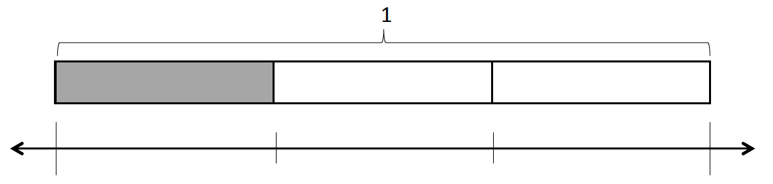Label each number line with the fractions shown on the tape diagram. Circle the fraction that labels the point on the number line that also names the shaded part of the tape diagram.

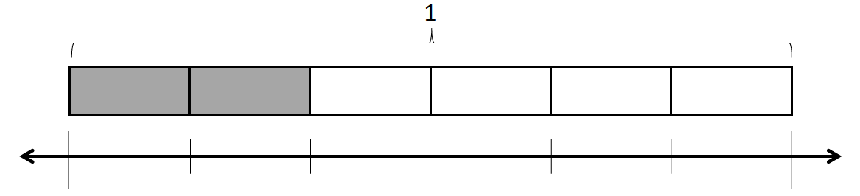



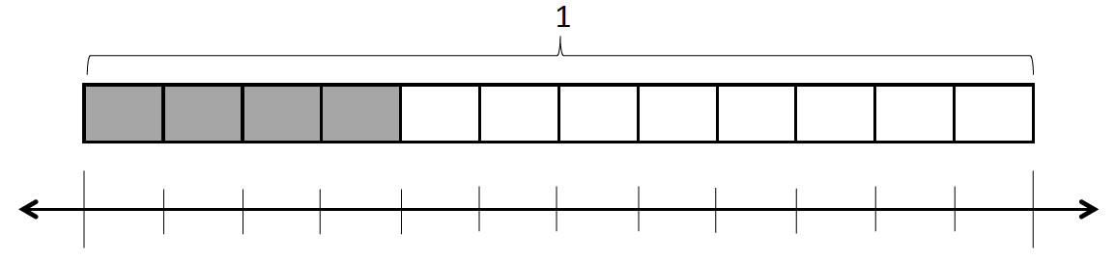

1. Write number sentences using multiplication to show:
2. The fraction represented in 1(a) is equivalent to the fraction represented in 1(b).
3. The fraction represented in 1(a) is equivalent to the fraction represented in 1(c).
4. Use each shaded tape diagram below as a ruler to draw a number line. Mark each number line with the fractional units shown on the tape diagram, and circle the fraction that labels the point on the number line that also names the shaded part of the tape diagram.

1

|  |  |  |  |
| --- | --- | --- | --- |
|  |  |  |  |

1



|  |  |  |  |  |  |  |  |
| --- | --- | --- | --- | --- | --- | --- | --- |
|  |  |  |  |  |  |  |  |

1

|  |  |  |  |  |  |  |  |  |  |
| --- | --- | --- | --- | --- | --- | --- | --- | --- | --- |
|  |  |  |  |  |  |  |  |  |  |

1. Write a number sentence using division to show the fraction represented in 3(a) is equivalent to the fraction represented in 3(b).
2. a. Partition a number line from 0 to 1 into fourths. Decompose $\frac{3}{4}$ into 6 equal lengths.
3. Write a number sentence using multiplication to show what fraction represented on the number line is equivalent to .
4. Write a number sentence using division to show what fraction represented on the number line is equivalent to .